Wash

Your

Hands

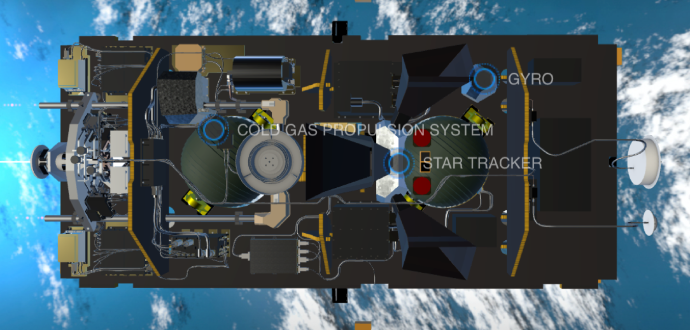

GPS_nav_ant

Black Box in

End brac

Black Box cl

Micro_back_s

Micro_back_L

Black box upper

Gyro

Black Box end

Black Box

Tank1/tankmetal1

Tank2/tankmetal2

ST1

LRI other2

LRI brac2

LRI brac1

LRI and LRI baffle

Not Sure

LRI bat

IPU2

USO2

IPU1

USO1

Microwave Ranging

